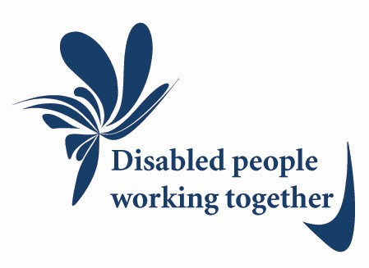

Disability Forum
for
Suffolk

A network of disability organisations, disabled
people and family carers working together to:

•
Improve the lives of disabled people and
their families in Suffolk;
•
Share knowledge, expertise and information;
•
Develop a stronger and more united voice;
•
Deliver existing, new, and improved services;
•
Provide more integrated services;
•
Achieve more than we could do alone.

Who can join?

Membership is open to both organisations who work with disabled people and their family carers and individual disabled people and their family carers. It is not necessary for members to belong to an organisation.

Members of the Disability Forum for Suffolk will share the following values:

- Be inclusive and recognise and work with diversity in terms of race, religion and belief, gender, sexual orientation, disability and age;
- Promote people's human and other rights, dignity and respect;
- Work from a Social Model of Disability;
- Promote informed choice and control with advocacy and support;
- Value peer support as an integral part of any services provided;
- Involve disabled people in strategic decision making;
- Cover all local disabled people and their family carers who use support either directly or via establishing links with other local organisations or networks;

- Recognise that family carers have their own needs and requirements as carers;
- Recognise that all decision making processes should be user and/or family carer led - 'Nothing about us without us'.
Why belong?

So that, together, the Disability Forum for Suffolk members can:

- Create a strong and united voice for disabled people in Suffolk to campaign on disability issues.
- Work together with other disabled people who understand the barriers first hand so we can help each other to speak up and make choices;
- Share the advice and information disabled people need to live their lives and access the right services;
- Share expertise and resources with each other;
- Tackle discrimination;
- Promote equality and tackle the barriers which disable us
- Work strategically to maximise influence and ensure that disabled people and family carers can make real improvements to the lives of disabled people.

To join the Disability Forum for Suffolk please ask us for a form where you can register your interest.
The Disability Forum for Suffolk can be contacted via Avenues East on 01473 836777 or via email at:
disabilityforumsuffolk@btinternet.com
You can also download the application form and get more information at:
http://disabilityforumsuffolk.onesuffolk.net/about-us/
Please contact us if you need this leaflet in a different format.

