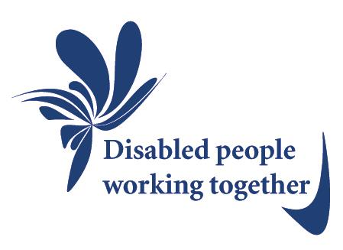
The Disability Forum for
Suffolk

Our Vision

The Disability Forum for Suffolk is a network of disability organisations, disabled people with different impairments and family carers working together to:

- Show by example what disabled people achieve when barriers and discrimination are removed;
- Empower ourselves to drive change, by sharing our knowledge skills, energy and resources;
- Ensure that the voices of all disabled people whatever their impairment and their family carers are equally heard and their views properly valued;
- Make sure disabled people are treated equally within the social model of disability, without discrimination;
- Create choice for disabled people to play a full part in work, family life and all levels of society;
- Work with councils, commissioners, business and service providers to deliver real improvements in disabled people’s lives;
- Provide support and assistance to the local Disability Forums in Suffolk in order to respond to and co-ordinate their issues.

The Disability Forum for
Suffolk

Our Vision
Our vision is disability organisations, disabled people and family carers working together to:
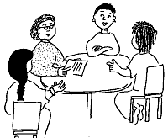
- Show we can do great things
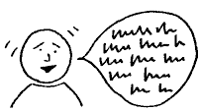
- Share important things we know and help each other

- Make sure we are listened to
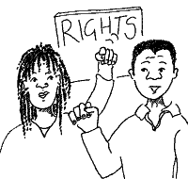
- Make sure there is no discrimination against us
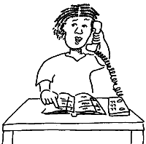
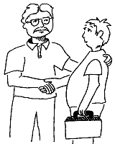
- Let us take part in the community if we want to.

- Work with local councils, health and business people to make a real difference

