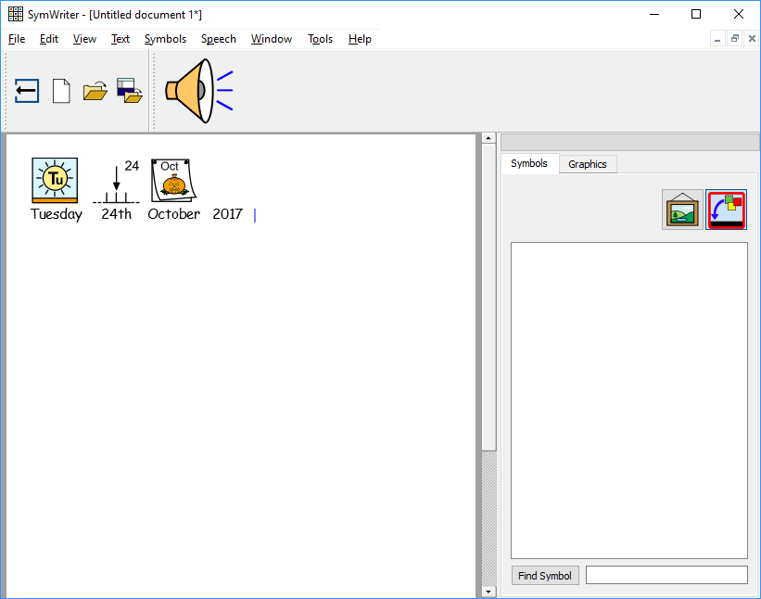**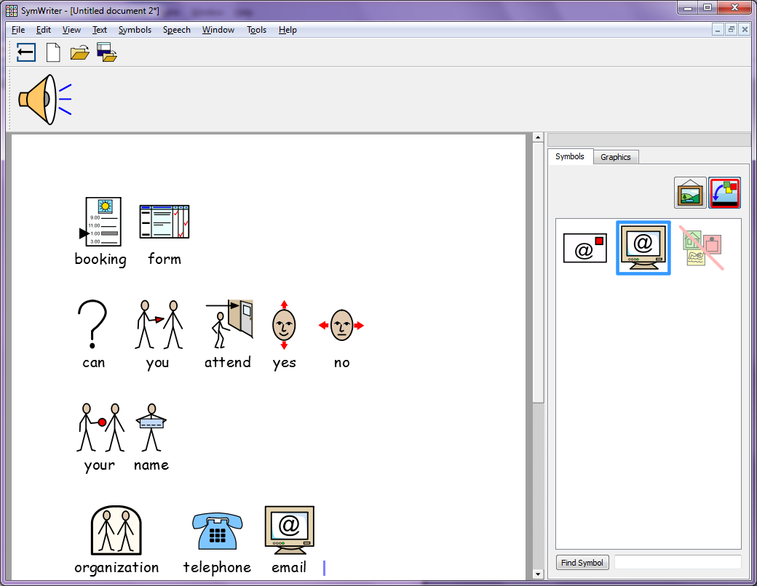**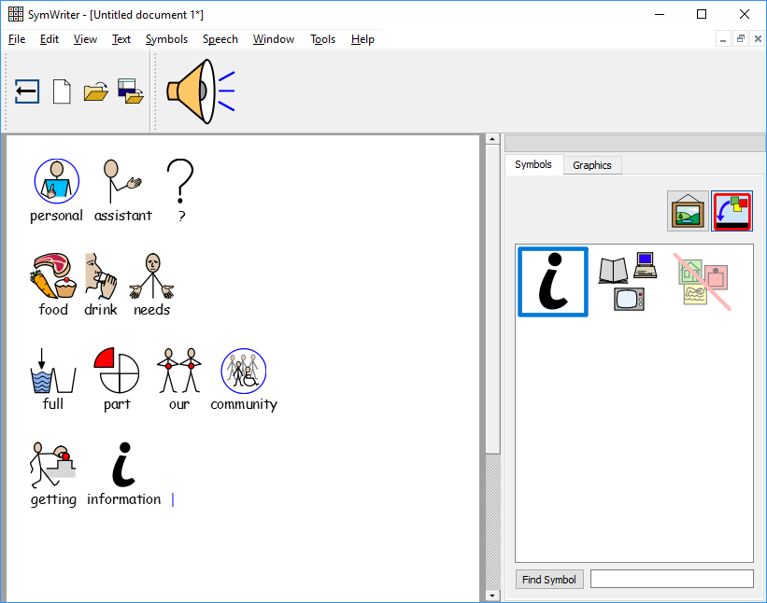****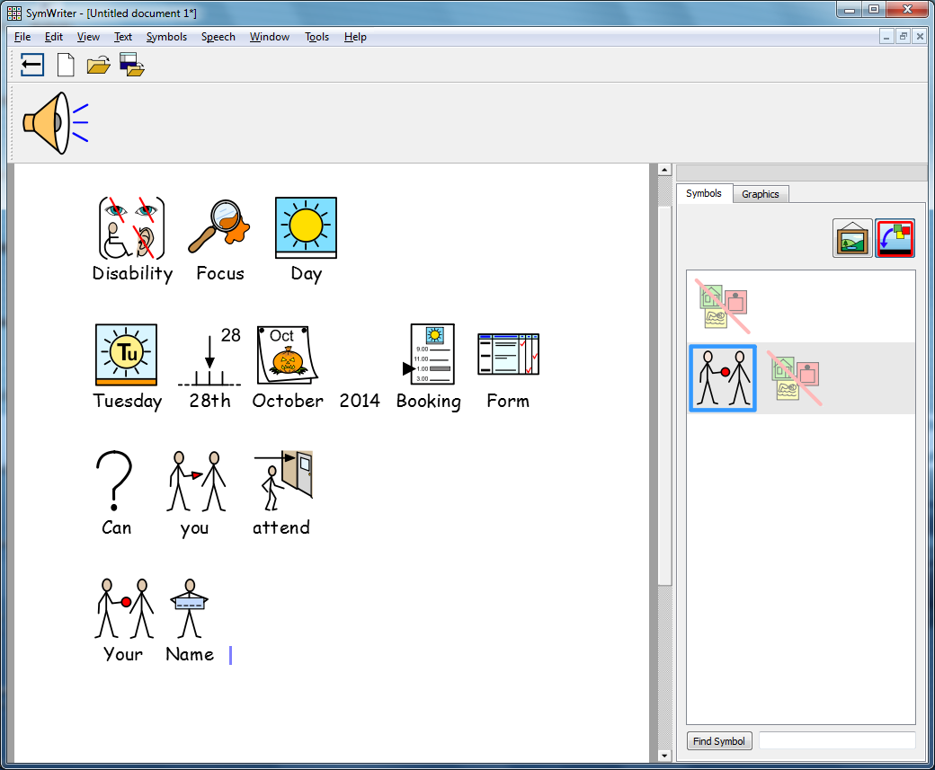

**Tuesday**

**2018**

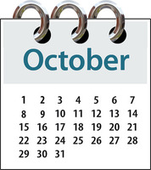

Yes

Yes

No

No

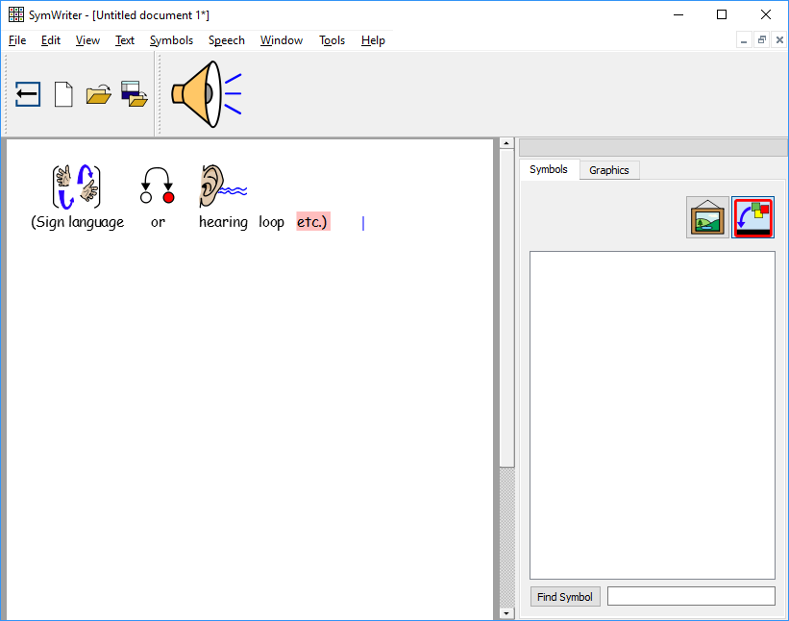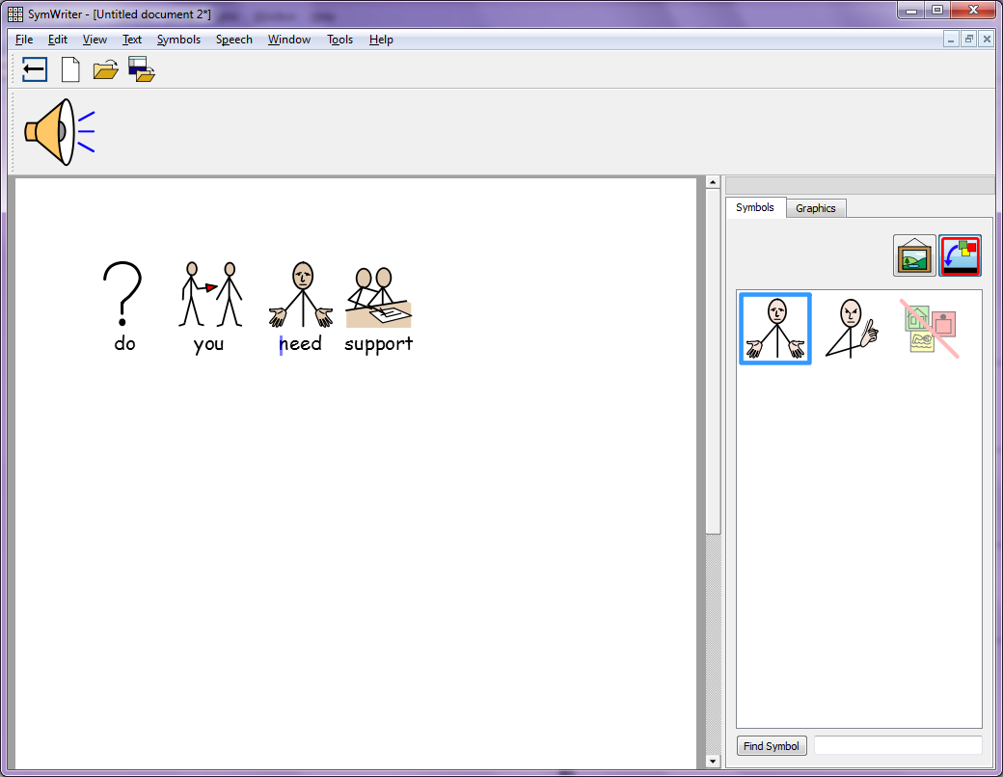****

Yes

No

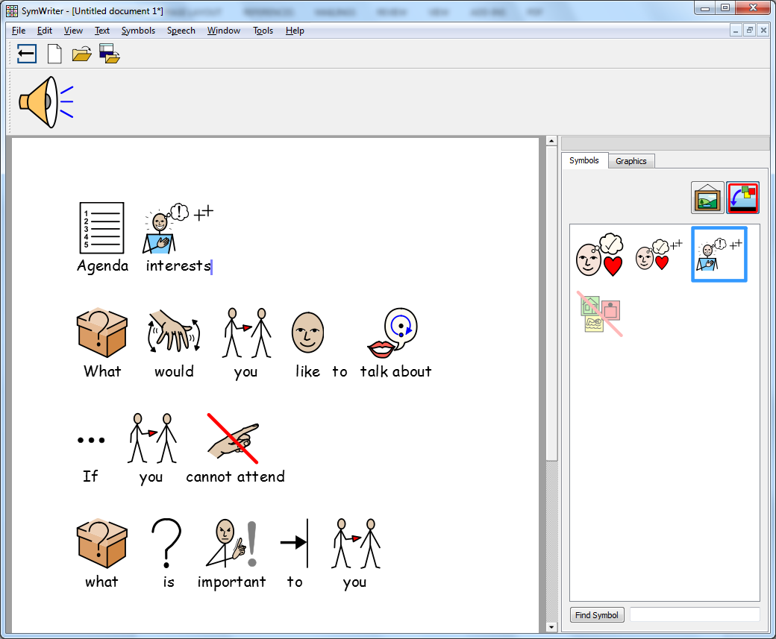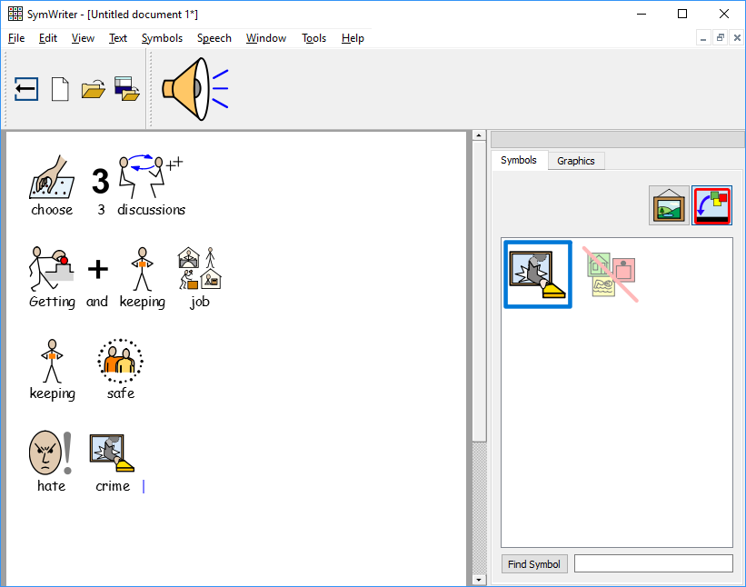

|  |  |  |  |
| --- | --- | --- | --- |
| **Topic** | **1st** | **2nd** | **3rd** |
| Being a full part of our community |  |  |  |
| Getting information  you can use |  |  |  |
| Getting benefits you are entitled to |  |  |  |
| Using hospital services |  |  |  |
| Using health care services (not in hospital) |  |  |  |
| Having a house & support to live there |  |  |  |
| Getting a job and  keeping it |  |  |  |
| Being safe where you  live and where you  spend your time |  |  |  |
|  |  |  |  |
| Using public spaces  and places |  |  |  |
| Getting to where you want to go |  |  |  |
| Support for family carers  S:\lores_images\Family.jpg |  |  |  |

**If you are unable to come, please tell us about issues that are important to you that you would like to raise**





|  |
| --- |
|  |
|  |
|  |
|  |
|  |

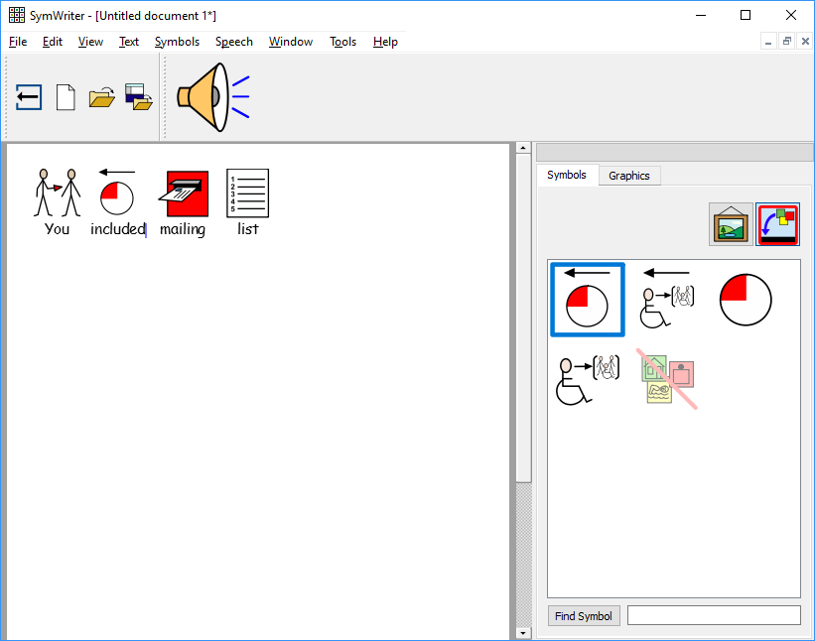

**Please email this form back to**

[**trish.hayward@avenuesgroup.org.uk**](mailto:trish.hayward@avenuesgroup.org.uk)

**By 12th October 2018**

No

Yes