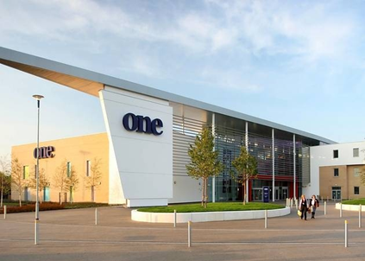

**Disability Focus**

**The Disability Focus Planning Group,**

**Avenues East and the Disability Forum for Suffolk**

**would like to invite you to take part in a day of lively discussion and debate about disability in Suffolk**

**Tuesday, 24th October, 2017**

**10am to 3pm at:**

|  |  |  |
| --- | --- | --- |
| **One**  **(Centre of Learning)**  **Scrivener Drive**  **Ipswich IP8 3SU** |  | |
| This is your chance to tell our local councils, the NHS, the Police and other statutory organisations about the issues that concern you or your organisation, so do come along and have your say. All individual disabled people, family carers and representatives of disability organisations are welcome. | |  |

Lunch and refreshments will be provided. There will be no charge to attend. There will also be a range of information stalls.

To book your place please email [trish.hayward@avenuesgroup.org.uk](mailto:trish.hayward@avenuesgroup.org.uk) by 13th October 2017 <http://disabilityforumsuffolk.onesuffolk.net>